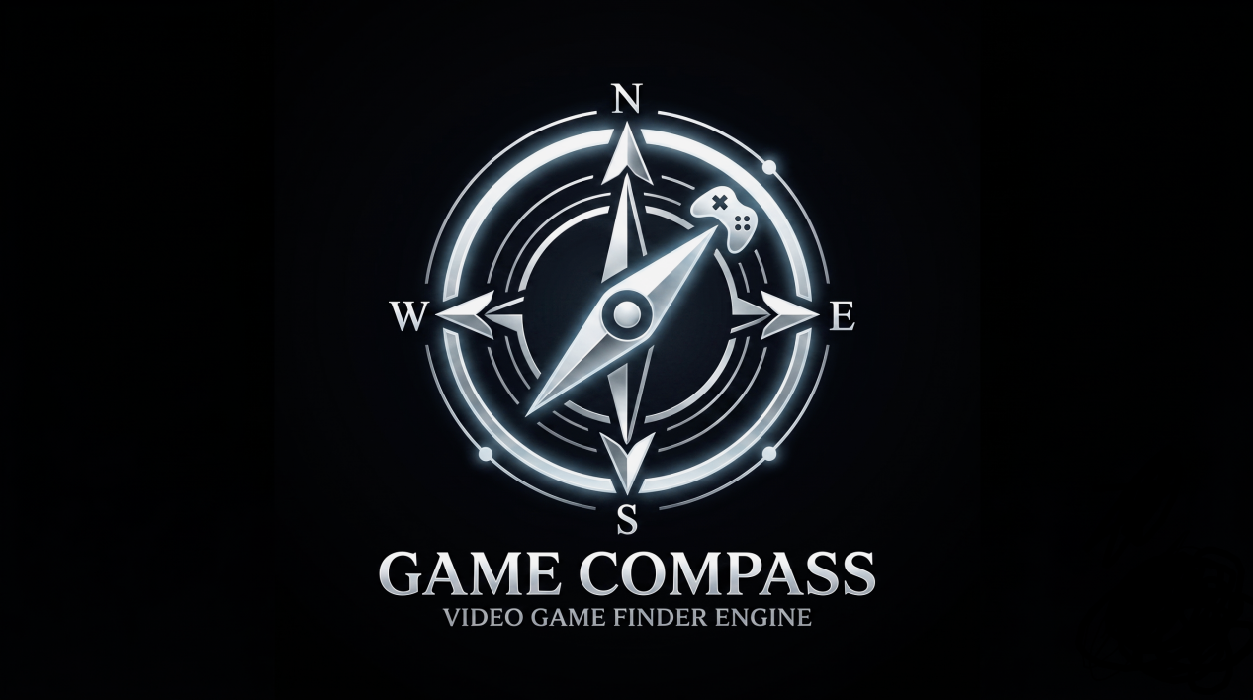

Game Compass

Chapter 1 : Introduction

  - Background (Motivation and Need)

The digital entertainment industry has experienced exponential growth, with storefronts like Steam, Epic Games, and PlayStation Network hosting tens of thousands of software titles. However, the foundational technology driving product discovery on these platforms relies heavily on outdated, keyword-based relational databases. Currently, users are forced to navigate rigid, developer-assigned metadata tags (e.g., "Action," "RPG," "Survival").
This creates a severe "lexical gap." If a user desires a specific gameplay experience but uses natural language that does not perfectly match the database's exact keywords, relevant products remain hidden. Furthermore, traditional storefront ranking algorithms default to simplistic metrics like "Highest Rated" or "Most Popular," which heavily biases massive AAA studios and leaves the system vulnerable to manipulation, such as review-bombing or data sparsity anomalies (where an item with minimal reviews artificially inflates to a 100% rating).
The motivation behind Game Compass is to modernize digital product discovery by transitioning from lexical keyword matching to semantic intent comprehension. By leveraging recent advancements in Natural Language Processing (NLP) and Machine Learning (ML), there is a critical opportunity to build an engine that understands the "vibe" and contextual meaning of a user's query, providing a fairer, more accurate, and highly optimized recommendation pipeline.
Also , what we have seen is how due to Steam’s generic searching a lot of indie gems get buried. But with our AI - Powered search engine you can easily look for these titles and also discover new games that suit your mood or your play style. Hence, it personalizes your game choices and gives you the exact thing you are looking for without any hassle .

1.2 Problem Definition and Objectives

Problem Definition
Current e-commerce and digital media search engines suffer from two critical architectural flaws and with this we list out the problems we tend to solve :-
- The Semantic Disconnect: Traditional IR systems rely on exact string matching. They cannot map the conceptual similarity between distinct phrases (e.g., failing to connect "brutal tropical endurance" with "hardcore island survival").
- The Trust Metric Anomaly: Sorting algorithms lack statistical nuance. They fail to apply multi-attribute utility, allowing unverified, low-volume datasets to outrank statistically significant, heavily reviewed datasets.
Game Compass addresses the challenge of building a lightweight, two-stage semantic retrieval and ML-driven connection system that helps you get what you are looking for as these game sites don’t have a way for a user to describe the game he wants to play. You need to know the exact Title of the game in order to buy it.

Objectives
The objectives of this project are as follows :
1.To build an Information Retrieval pipeline that uses NLP (Sentence Transformers) to convert game descriptions into mathematical vectors, allowing us to search by meaning instead of just keywords.
2.To implement a vector search model that compares a user's natural language query against our data set to find the most relevant games based on context.
3.To create a Machine Learning re-ranking algorithm that normalizes community review scores and total player volumes to filter out skewed or low-quality data.
4.To design a dynamic scoring formula that balances how well a game matches the user's text query with how much the gaming community actually trusts it.
5.To develop an interactive, dark-mode web application using Stream lit where users can easily test the search engine and adjust ranking weights in real-time.
This way our IR-ML based Engine is designed to solve both the lexical gap and the trust anomaly in unstructured text databases.

1.3 Social & Environmental Relevance

1. Democratizing the Digital Economy for Solo Developers
Traditionally the algorithms favour massive AAA companies with multi-million dollar marketing budgets . If a game doesn’t get 10,000 players on Day One it assumes it’s a dud game. But we have just the right thing as Game Compass searches by meaning and scales reviews accordingly as well as their sales . So, a masterpiece of an indie game has same chance as $ 200 million Cyberpunk. So, it enforces Digital equity, monopolistic storefronts, indie developer visibility, merit-based discovery.

2. Combating Algorithmic Manipulation and "Review Bombing"
Internet is plagued by malicious data which often leads to angry users “review bombing” games for political or irrelevant reasons , instantly tanking it’s score . Also converse of this is true is well as developers can buy fake reviews to artificially boost game’s ranking.
To counter this malpractice our engine normalizes the data and allows the user to adjust the "Volume Trust" weight, the system mathematically smooths out these anomalies. It creates a more ethical, transparent digital environment where users can filter out the noise.

3. Reducing Cognitive Overload in the Digital Age
These Days most of us suffer from “Choice Paralysis” . When we are given a ton of choices and we struggle to choose , resulting in us getting over-whelmed .
So, what what we are doing is making sure that people can freely type what they want to play and hence making sure that there is no in between user’s mood and their recommendations . This is the major point of our project and our main goal. By making the engine not companies based but user-based , so it pleases the users not the corporations.

Broader Applications in E-Commerce and Healthcare
First of all I would like to say that video games shouldn’t be treated as a small market or a niche market as it is projected to reach $ 577.91 billion by 2026 according to Statista . Hence , should be taken seriously as any other major commodity.

Secondly, This exact architecture used in Game Compass can be sold to other industries. A hospital could use this to search patient records ("Find me cases with symptoms similar to a mild chest flutter") , Real estate agents could use it ("Find me a house that feels modern but has a rustic backyard"). So, basically helping people to get what they are looking for as accurately possible.

Computational Efficiency and Environmental Impact (Green Computing)
This idea of having a massive SQL Database that runs thousands of keywords across millions of users takes massive server power and hence burns electricity , creates noise pollution , uses water as coolant and harming the environment.

Here our vector-search shines as it is computationally cheap and cosine similarity takes milliseconds to calculate the score and process a user’s query . Hence, having a reduced Carbon Footprint and practicing “Green IT” ; Which contributes to a Healthy Planet and Betterment of Mankind.

As, we care about the planet and want sustainable development that doesn’t hurt our beautiful Blue planet that we call our “home”.

1.4 Project Plan

1.4.1 Work Breakdown Structure (WBS)
Phase 1: Requirement Analysis & Data Acquisition: Downloading the Steam dataset, defining mathematical parameters, and establishing software dependencies.
Phase 2: Data Pre-processing (Jupyter Notebook): Cleaning the dataset, handling null values, and calculating raw review metrics using Pandas.
Phase 3: AI/ML Integration (Backend): Implementing the Hugging Face Sentence Transformer for vector generation and utilizing Scikit-learn for Min-Max Normalization.
Phase 4: UI/UX Development (Front end): Building the Stream lit interactive dashboard, integrating the logo, and linking the UI sliders to the ML mathematical weights.
Phase 5: Testing & Documentation: Validating pipeline accuracy, optimizing GPU tensor execution, and finalizing the project report.

1.4.2 Timeline (as we expected it to go like)
Week 1: Project Synopsis, Environment Setup, & Dataset Acquisition.
Week 2: Dataset Pre-processing & Cleaning.
Weeks 3-4: AI/ML Integration (Vectorization & Normalization math).
Week 5: UI/UX Frontend Development (Streamlit dashboard).
Weeks 6-7: Testing, Bug Fixing, UI Polish, and Final Report Writing.

1.4.3 Roles and Responsibilities

Team Member | Responsibility
Bitthal Bhai Vinayak | Backend Logic & IR phase execution (Data pre-processing, Transformer integration, and vector space math).
Keshul Gupta | ML phase execution & Frontend (Min-Max normalization logic, Streamlit UI/UX design, and system integration).

1.4.4 Challenges and Risk Management

Risk/Challenge | Impact | Mitigation Strategy
Hardware Memory Overflow | Medium | Utilize batch processing in Pandas; force PyTorch to utilize the dedicated GPU instead of system RAM.
Dataset Noise/Null Values | High | Implement strict data cleaning scripts in Phase 1 to drop games with missing descriptions or zero reviews before matrix creation.
Latency in Search UI | Medium | Pre-compute and save the 384-dimensional vector matrix locally as a .npy file so the app does not re-encode the entire database upon every search.

1.5 Scope and Limitations

Scope
- The project swill focus exclusively on PC games sourced from the localized Kaggle Steam dataset (approx. 122,000 titles).
- The system will process English natural language text inputs only.
- The ranking engine will factor in semantic contextual scores, positive review ratios, and total review volumes.
- The final output will be a localized web application running via Streamlit.

Limitations
Static Dataset: The application relies on a downloaded .csv file. It will not dynamically update in real-time if a new game releases on Steam tomorrow (unless the database file is manually updated and re-vectorized).
Hardware Compatibility Matching: The engine recommends games based on "vibe" and community trust. It does not scan the user's PC to determine if their graphics card is powerful enough to actually run the recommended game.
Language Barrier: The pre-trained NLP model (all-MiniLM-L6-v2) is highly optimized for English. Queries in Hindi, Spanish, or other languages will yield highly inaccurate cosine similarity scores.

